# The Application

Taking advantage of all the technologies, packages, libraries and tools mentioned above, we took the first step towards our final destination by developing the fundamental application, capable of collecting, processing and storing all the necessary data, through which we hope to reach our end-goals. Although, at least for the Machine Learning aspect, the application might appear more as a means to an end, that does not imply however that there is not a substantial importance to its proper development, as it is essentially meant to be used by the end-user and not to be a simple tool for the researcher to simplify their work. In addition, certain elements of the application are meant to provide a more direct benefit than what the Machine Learning aspect might offer, at least in the sense that it is provided imminently and with no need of peering into the user’s historical data.

As such it is important to note that the application was not designed specifically with the purpose of constituting the cornerstone of a system set to collect, process and store data in suitable form to later be used for Machine Learning purposes. On the contrary, Machine Learning is merely an aspect of the whole system. Therefore, one good way to view the whole application is as if it is divided in modules. In the context of this thesis, some modules have been fully implemented, others had to be either left in theory or partially implemented, as sometimes it was simply impossible to implement some sub-systems that required extensive testing to be proven useful or not, something that in turn would require funds and people that cannot be available and neither they should be available in the context of a MSc thesis such as this. They are however expanded upon, partially in this segment, but mostly in the future work near the end of the document. They are not, in anyway, downgraded in terms of importance, they are simply impossible to be implemented and proven by the efforts of one person.

The fundamental idea was the creation of a system capable of combining many aspects of modern dieting, either with the hope of simplifying them through one, easy-to-use application, or even increase their potency by augmenting one through the other. Such a system would offer immense expansibility, capable of incorporating all aspects of dieting, new or old, while at the same time, due to its modularity and optionality, not becoming too burdensome to the user.

All things considered, the application offers unique benefits to the following type of users:

* Simple, end-users or ‘patients’
* Advanced, end-users or ‘professionals’
* Researchers, developers.

## Food Logging

Food logging can be considered the very basic function of the application. At the very least, users can use it simply as a means to log their food intake and their exercise status. It is easy to use, offers NLP capabilities through the EdamamAPI implementation and automatically logs it into the system, with all possible nutrient details. As such it provides a considerable simplification of the process that one would have to follow if they were to manually input their eating habits by hand, in paper, as dietitians mostly require their patients to do today.

The immediate benefits of using this system are:

* The user needs not to write, but to type and with NLP capabilities, this becomes simpler.
  + Many times something as simple as not having a pen or a piece of paper in hand can be the determining factor. Through the application however, access is available anytime, anywhere.
* The user may input their intakes the moment of consumption.
  + As such “fuzzy memory” issues are avoided, as it is a common thing for people to forget something they might ate. Again, the ability to log anytime, anywhere proves to be crucial, especially when away from home.
* Provides a reminder of what was consumed, of the number of calories consumed and as such accessing the log can be crucial at avoiding a detrimental food intake.
  + In cases where people log before they eat, or even right after, they might realize that they are overextending their boundaries and as such reduce their food intake.
* Consists of an easy, portable food diary.

## Professional Supervision

Separating the users between ‘patients’ and ‘professionals’ was something aimed at benefiting both at the same time. As mentioned, the initial idea of this system was to provide a universal, all-in-one way to bring different aspects of dieting together with the goal to either simplify the hurdle, or even augment the benefits. As such, on one hand one should look at the benefits for a professional to use this application to help himself and his patients and on the other, the benefits of the patients themselves.

For the professional, this application can, in its simplest form, consist of a patient book. The professional dietician or nutritionist can access their patients’ food diaries live and see their progress, or transgressions, anytime they desire. In a field where innovation is of key importance and incorporating technology is considered professionalism and an indication of quality, being able to offer your customers the ability to monitor them live and provide feedback on demand could very well be the deciding factor in choosing them over the other. Surprisingly, this might also be of immense benefit to the customer, even if the communication between the two is as limited as it can be. Simply enough, the fact that his dietician or nutritionist is next to him all the time can be a motivating factor, or a very desired ‘fear’ to keep oneself in check. It is no secret that most people fail at keeping a diet alone. Having someone with them (figuratively) most of the time can motivate someone and push them into maintaining their diet. Incorporating human social elements and forming an active connection can very well be the ‘short-term benefit’ factor one would otherwise lack in a solitary pursuit of dieting. Most importantly however, is that this active interaction is completely optional. The system itself still provides immense usefulness for a professional when they need to make a decision regarding the future of their patient. The ability to see what they ate and when, if they stumbled and how, might provide them key insight on their patient’s peculiarities and be able to adapt to them. Usually this is something that happens orally, days or even weeks after the incident and therefore it is very prone to human error. Through the application however, the professional is guaranteed to have a much more indicative representation of their patient’s bad and good habits.

Additionally, professionals can set goals (in terms of calories and nutrition quotas) that the user will be able to see during their food logging. This might prove crucial in them picking the right foods over the ones that would harm their diet. This is also enhanced by the ability of the EdamamAPI of providing nutritional details to the user, the moment they log a new food. It is indeed a recurring theme, that by bringing all these different aspects of dieting together (food logging, communicating with a professional, etc.) enhances each one individually and all together at the same time.

Practically, a professional doesn’t have to exist. They may even come in later and what a great start it would be to grant them an insight on their customer’s past right off the bat. This might even cut the process of learning each other to a bare minimum. It also makes sure that valuable work is not simply lost. It can be maintained and used later on.

## Machine Learning

Machine learning, in the case-by-case basis, is meant to provide insight to the user, to aid and guide them away from potential mistakes. In the broader sense however, Machine learning could potentially open up new possibilities, by noticing patterns unknown to scientists and people of the industry, some of which could very well spark debates and researches. Machine Learning is, in some sense, the wildcard, the what-if, made sustainable by its ability to occasionally provide extraordinarily accurate but always amusing, insight to the end-user, something that might be underestimated by everyone but the users themselves.

As mentioned, if something can be considered absolutely necessary for the system to work, is user interaction. In many fields, interaction is in one way or another guaranteed. To gather all the necessary input, for instance, might just be a day’s work. Or it may require one simple action per day, for some days. When it comes to dieting however, it has been proven and arguably, it needs not to be proven anymore, that user engagement is an end-goal by itself. People are not very keen to put up with food logging for long. This could be very easily attributed to the short-term and long-term benefits problem. Most people are wired to seek short term benefits, but food logging is an arduous task that pays out, if it pays out, long term. At the same time, if user activity is required for the system to work properly, then this issue can very well jeopardize the entirety of the system, in ways as equally catastrophic as a security threat would.

Therefore, machine learning should not and, in the context of this thesis, it is not viewed as a researcher’s box of premium, limited-time chocolate candies. On the contrary, Machine Learning, in all its wonderful ingenious and paradoxical outcomes, can become a tool to skyrocket user engagement.

# Presentation

## Home Page

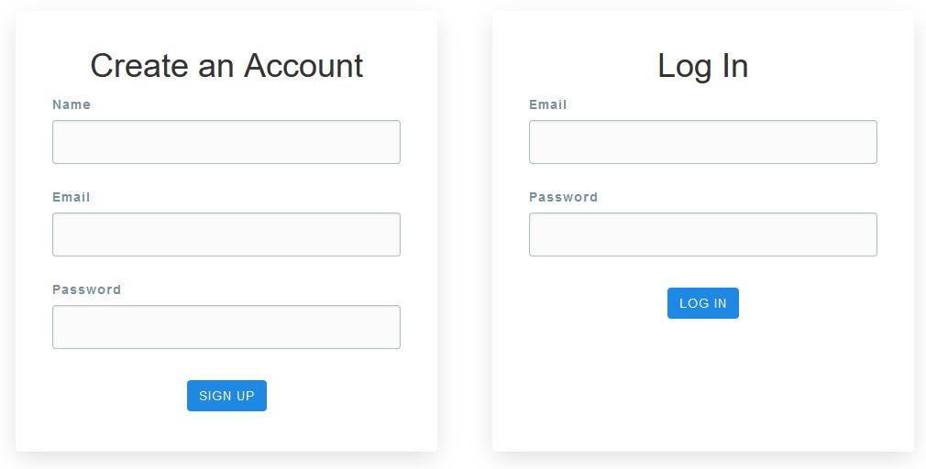

Figure 1: Home Page

Upon entering the site, the user has to either log in, or create an account. This can vary easily be done by providing a name, an email and a password. As mentioned before, the application makes sure that the password is not simply saved into the database and thus consist a potential security threat. The Passlib.hash module is utilized and as such, through the pbkdf2_sha256 hashing option, the passwords are saved in a secure manner. An additional check would be to check for the validity of the email given. This can be done in a variety of manners, the simplest of which is to send a verification email and only complete the registration upon him responding by clicking a certain link. Another manner would be to allow connection through certain social media outlets like Facebook and Instagram.

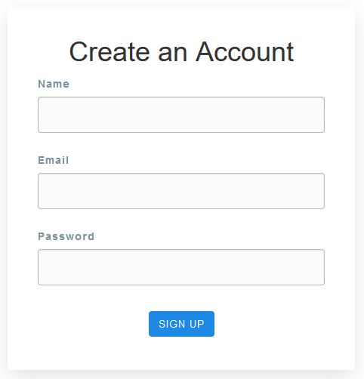

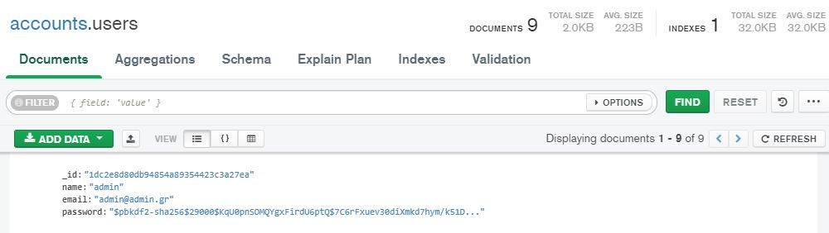

Figure 2: MongoDB registration for Admin (password hashed)

## Dashboard

Upon logging into the application, the user comes face-to-face with the dashboard.

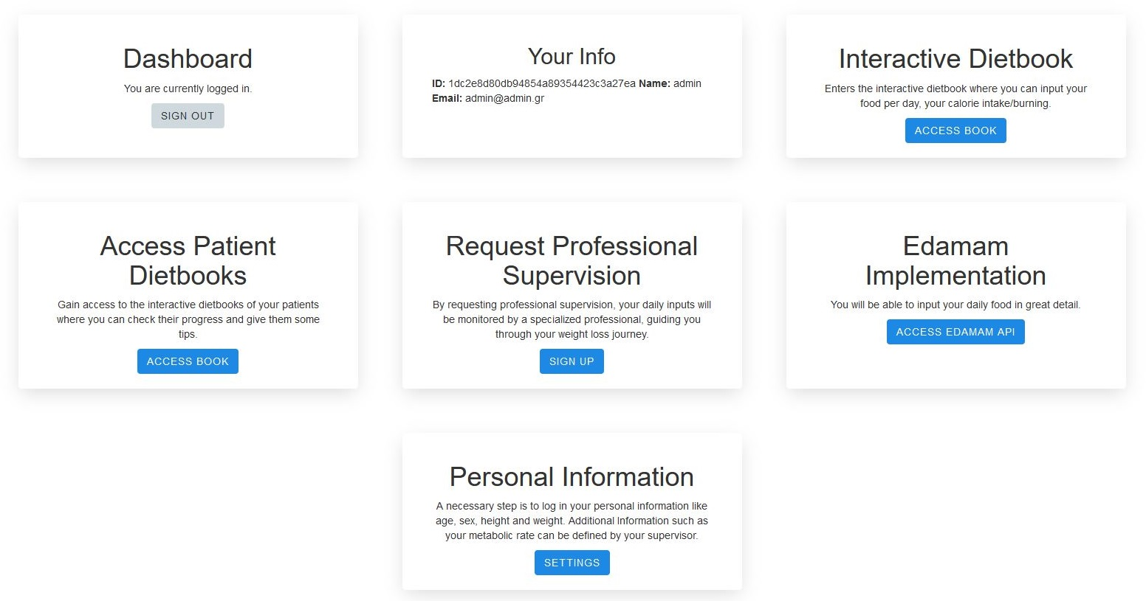

Figure 3: The Dashboard

## Personal Information

For every new user it is highly advised to log in their personal data which can be done in the last card/panel. The user is initially required to log his biological sex, his age, his height and weight. These are deemed the most important characteristics for the basic functions of the application and as such are highly advised to be filled. They are not necessary per say, but it will hinder the system at providing accurate estimates on a variety of things, like calorie burn in exercise, calculation of BMI, etc. Generally speaking, things that are better left to professionals such as average daily calorie consumption, body fat mass and so forth are left for the professionals to fill, unless the users themselves insist on doing so. This however will trigger a flag on their account, marking them as self-monitoring individuals, which will not do anything drastic but inform the system during the Machine Learning part, that the user is self-monitoring.

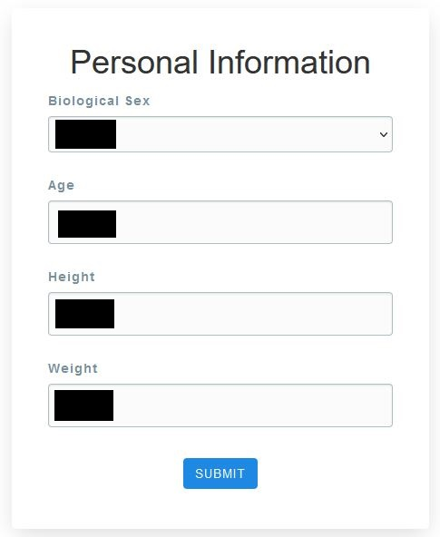

## Edamam Implementation

A simple, handy tool for the users to check, on-the-fly, the calorie intake of a certain food. Rather than wasting time inserting a food in their food diary, then can simply check its calories by a simple query to the EdamamAPI. In addition, the user may

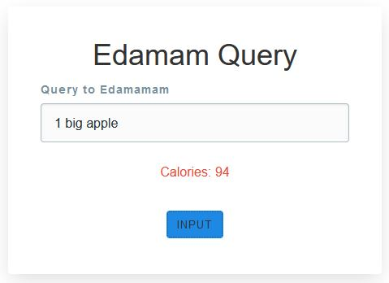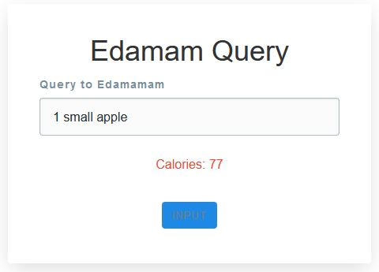

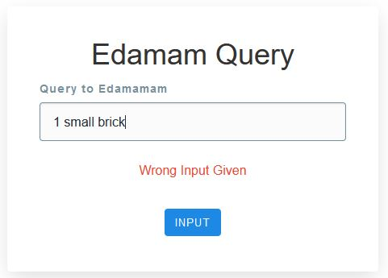

## Request Supervisor

Subsequently, the users may request a supervisor, an act that will tie their account with that of the professional, making it possible for them to appear on the supervisor’s list

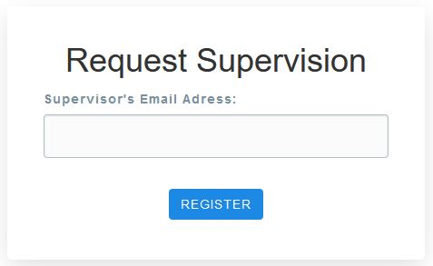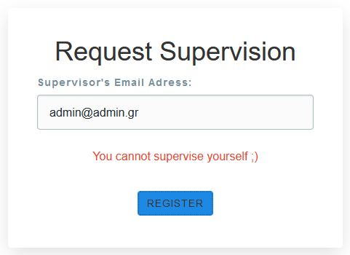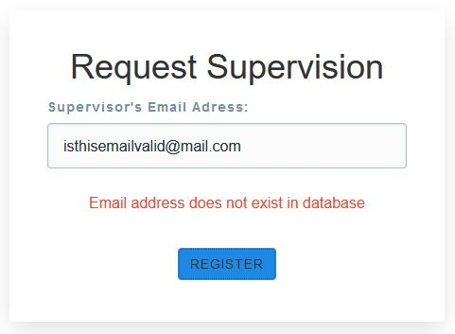

## Access Patient’s Dietbook

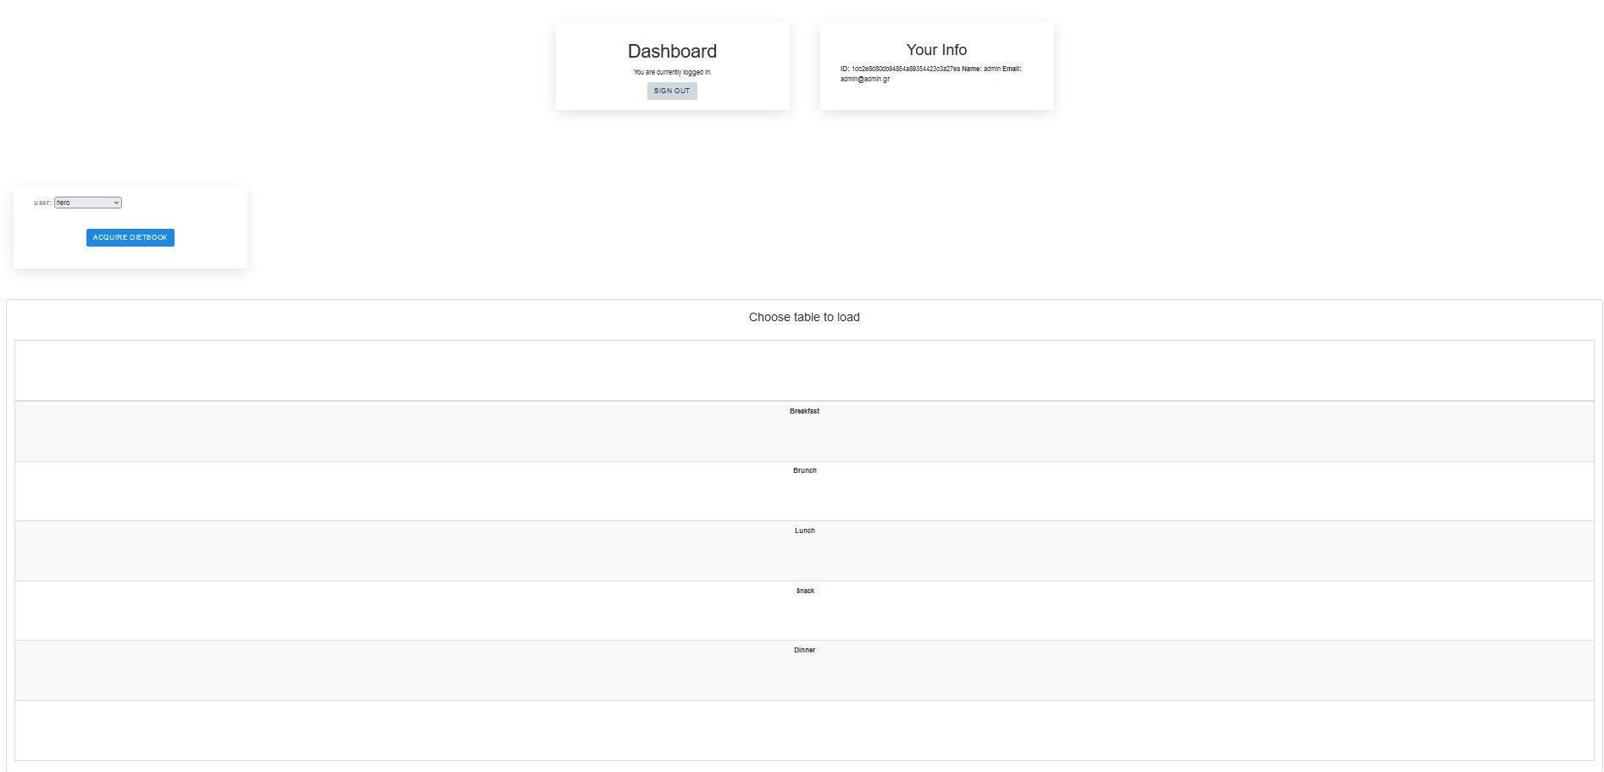

Figure 4: Access Patient's Dietbook

A card/panel unique to registered professionals, it provides the main way of accessing their patient’s dietbooks and viewing their progress.

## Dietbook

# Bibliography